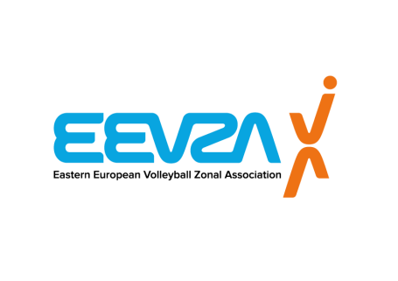 | 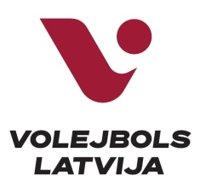 | 
2023 EEVZA U18 and U16 Beach Volleyball Championship
PRACTICAL INFO
EVENT’S TITLE | 2023 EEVZA U18/U16 Beach volleyball Championship
VENUE | “O-sands” Beach volleyball courts, Skanstes street 12, Riga, Latvia
DATE | 08.-09.08.2023
LOCAL ORGANISER | Volleyball federation of Latvia  Web: www.volejbols.lv  Phone: +371 67869774, e-mail: lvf@volejbols.lv
EEVZA | Eastern European Volleyball Zonal Association  http://www.eevza.eu/  Secretary General, Mrs. Inara Brokane  E-mail: secretarygeneral@eevza.eu  EEVZA Beach and snow volleyball coordinator, Ms. Alisa Cesnuleviciute  Email: info@ltf.lt
NATIONAL FEDERATION | Volleyball federation of Latvia  Web: www.volejbols.lv  Phone: +371 67869774, e-mail: lvf@volejbols.lv
REGISTRATION | To be admitted to participate in the competition, the National Federation must complete a Registration Form with the names of players, duly signed and stamped by concerned National Federation. All teams from EEVZA countries who are interested to participate, should send an official request (also WC requests) through their National Federation to following e-mails:  To: info@ltf.lt  Cc: secretarygeneral@eevza.eu  Deadline: 25.07.2023
ORGANIZING COMMITTEE | Organizers’ Area  Tournament Director Edgars Zaizenijs +371 22034343 edgars@volejbols.lv  NF Delegate: Edgars Zaizenijs +371 22034343 edgars@volejbols.lv  Technical and Administrative Area  EEVZA Technical Supervisor tbd  Technical Director tbd  Court Manager tbd  Referee Manager Aleksandrs Polevs +371 22426957 aleksandrs.polevs@inbox.lv  BVIS Manager Liene Libere +371 26750898 libereliene@gmail.com
REFEREES | NF Referee Manager:  Aleksandrs Polevs, +371 22426957, aleksandrs.polevs@inbox.lv  Local Referees: tbd
GENDER | Men/Women
RIGHT OF PARTICIPATION | - Players wishing to participate shall be aged under 18 years on 31st of December of the year during which the respective Championship is held (for this season born on 1st of January, 2006 or later);  - Players wishing to participate shall be aged under 16 years on 31st of December of the year during which the respective Championship is held (for this season born on 1st of January, 2008 or later);
CONTRIBUTION FEE | A contribution fee is a fee paid for each Main Draw  member to the organiser in order to contribute to its lodging, meals and local transportation. Delegation members are considered two (2) players and optionally up to one (1) team manager/coach per team. A daily contribution fee of 75,- EUR per official delegation member per day shall be paid for each team member by the respective National Federation to the Organiser for 3 days in total, even if the duration of the stay of its delegation members is shorter (Main Draw 3 x 75,- EUR = 225,- EUR).  The respective National Federation shall pay the contribution fee 7 days before the start of the event to the bank account of the Organiser, which will be communicated together with the Practical Info document. If the Organiser will not receive the fees in time, the EEVZA Supervisor has the right to exclude the concerned teams from the event.  Each participating National Federation has to present a copy of the confirmed money transfer to the EEVZA Supervisor at the respective Preliminary Inquiry.
COMPETITION FORMAT | The Main Draw Tournament of U18 men, U18 women, U16 men and U16 women is played through a Preliminary Round of modified pool play, followed by single elimination playoff.  The number of groups and the precise draw system will be determined according to the number of teams that have applied, which is a maximum of 18 teams.
NUMBER OF TEAMS | U18 men – max 18 teams, U18 women - max 18 teams, U16 men – max 18 teams, U16 women – max 18 teams
MAIN DRAW | Max 18 teams per gender U18 men/women and U16 men/women
COMPETITION SCHEDULE | Preliminary Inquiry & Technical Meeting (if any)  Men/Women: Athletes are required to attend the Preliminary Inquiry and the Technical Meeting (if any), to present the passports, uniforms and accessories, a copy of the confirmed contribution fee transfer.  All meetings will be held on the venue.  Preliminary Inquiry: 07.08.2023 from 18:00 to 20:00 p.m.
PRIZE OF HONOUR | The team winning the title of EEVZA U-18 and U-16 Champion will receive the medals and diplomas.
RULES OF THE GAME | FIVB Official Beach Volleyball Rules
OFFICIAL BALL | Mikasa Beach Pro BV550C
OFFICIAL DAYS  AND VENUE OF ARRIVAL AND DEPARTURE | Arrival for players: 07.08.2022  Departure for players: 10.08.2022 (or after the competition)
VISA | Players (and/or Team Managers/Coaches/National Federations) are requested to apply early enough for their visas, whenever needed.  The Host National Federation should be contacted to receive a letter of invitation or tourist invitation.  e-mail: edgars@volejbols.lv  Please send to Organizer of Event the following data:  - Full name as in passport (first name, last name)  - Date of birth (dd/mm/yy)  - Place of birth (city, country)  - Passport #  - Date of issue  - Valid till (min 6 months after visa date)  - Nationality  - Permanent address (street, apt. No. city, country)
UNIFORMS | The organiser will not provide uniforms to the participating teams, players should have minimum 2 sets of uniforms in different colours.  Uniforms must be presented during the Preliminary Inquiry.
INTERNATIONAL &  LOCAL TRANSPORT | The Organizer will provide local transport from the airport to the hotel and back for the Officials, referees, players, coaches and other official delegation members.  The Organizer will provide local transport from the hotel to the venue and back for the Officials, referees, players, coaches and other official delegation members.  Federation of participating teams is responsible for their international travel.
BOARD AND LODGING | The organizer will provide the teams with hotel accommodation (double room) and with meals.  Lunch on 08.08 and 09.08.;  Dinner on 07.08, 08.08. and 09.08.;  Cafe “Mr. Bobs” on venue, Skanstes street 12, Riga,  Dinner from 18:00 – 20:00  Lunch from 12:00 – 15:00
OFFICIAL HOTEL FOR TEAMS | Bellevue Park Hotel Riga  Distance from Hotel to the venue 6.2km  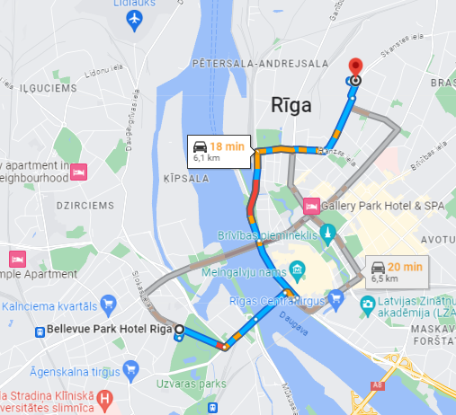
LOCAL TIME ZONE | UTC+2
WEATHER CONDITIONS | Min. Temperature: + 16 С  Max. Temperature:+ 32 С  Sunrise: 06:05  Sunset: 20:47
CURRENCY | EUR
TOURIST INFORMATION | https://www.liveriga.com/lv
EMBASIES | Embassy of Ukraine in the Republic of Latvia  Kalpaka bulvaris 3, Riga, Latvia, LV-1010  Phones +371-67-24-30-82, +371-67-33-29-56,  https://latvia.mfa.gov.ua/en  Embassy of the Republic of Azerbaijan in the Republic of Latvia  Raina bulvāris 2-5, Riga, LV-1050  Phone: (+371) 6714 28 89  E-mail: riga@mission.mfa.gov.az  https://riga.mfa.gov.az/en

